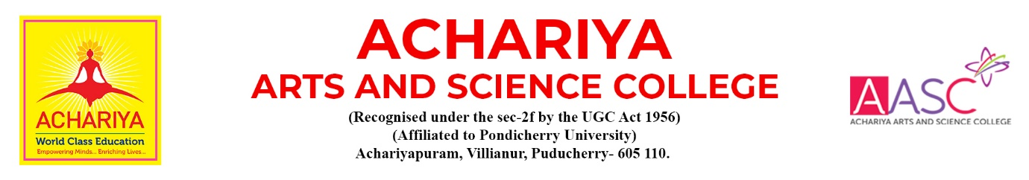

DEPARTMENT OF MANAGEMENT (BBA)

Annual Report for the AY 2024- 2025

1. Department of Management started with a clearly defined approach for creating quality managers and entrepreneurs required to face the challenges of the corporate sector. The department offers undergraduate courses in Business Administration which are specifically designed to develop and enhance career opportunities and to contribute the academic and applied knowledge in business management.

2. The I Year BBA Students attended 10 Days Orientation Programme organised by the College.

3. The I Year BBA Students MOHAN PRAKASH won I Prize in Elocution and PADMASUDHA won I prize in Essay Competition organised by the College.

4. The Department of Management celebrated ONAM, the harvest festival of Kerala with joy and happiness. The students of BBA did floral decorations (flower carpet) with lighting the traditional Kerala lamp and song.

5. The I Year BBA students attended ACETRONIX 2K24 organised by Achariya College of Engineering Technology, Pondicherry.

6. The students of II Year BBA attended a National Level Inter Collegiate Competition COMM EDGE-2K24 organized by the School of Commerce, Department of Commerce CA, Marudhar Kesari Jain College for Women (Autonomous), Vanyambadi and won II prize in AD-VENTURE event.

7. The students of II Year BBA participated an International Symposium INSIGHTX’24 organized by the Department of Management Studies of EGS Pillay Engineering College (Autonomous), Nagapattinam and won II Prize in STOCK WAR, III Prize in AD-ZAP and BEST MANAGER event.

8. The students of II Year BBA attended a National Level Academic Conclave GYAN KUMBH organized by the Pondicherry University.

9. The students of II Year BBA participated in SHAZAAM, 14th Inter Schools & Colleges Sports and Cultural Events 2024 organised by CK Group of Educational Institutions, Cuddalore and Ms. HARINI won II Prize in Grahan Thandav Solo Classical Dance Competition.

10. The students of II Year BBA participated in National Level Cultural Fest – LE CIEL organized by the National Institute of Technology Puducherry (NITPY), Karaikal. Ms. S AKSHYA won I Place in Perfect Pitch and II Place in Classical Singing and Ms. HARINI won II Prize in Grahan Thandav Solo Classical Dance Competition.

11. The students of II Year participated in DAKSHA’24 an Inter Collegiate Management Fest organized by the SSN School of Management, Chennai.

12. The students of II Year involved in putting up the Canteen facility an Extension counter in the college campus in enriching their entrepreneurial skills.

13. The Staff and Students of Department of Management celebrated CHRISTMAS, commemorating the birth of Jesus Christ, and a time for joy, love, and togetherness organised the College.

14. The Staff and Students of Department of Management celebrated PONGAL, the harvest festival thanking the Sun and Mother Nature that help to contribute to a bountiful harvest organised the Department of Tamil.

15. The I Year BBA Students AFFRIN, HANITHA, SWATHI and KANIMOZHI won I Prize in MIME in Nation Youth Day awareness programme organised by the Red Ribbon Club of the College.

16. The II Year Students of BBA organised and conducted COIN 2K25, MSME Conclave. Our pride stakeholders, the Parents of the II Year BBA Students were the Guest speakers for the 2 Day Entrepreneurs Interaction sessions.

17. The BBA students interacted with our Alumni Ms. PIRIYANGA S of 2015-18 batch on Goals and Targets of Life. She shared her oversees experiences of work life balance and abroad Career Opportunities.

18. The students of BBA attended GLOBIZZ’25 the Institute Industry Interface Meet organized by the Department of International Business, School of Management, Pondicherry l University.

19. The Staff and Students of Department of Commerce and Management organised and conducted ACHARIYA BUSINESS LEAGUE – ABL 2K25 the 10th Edition, Battle of Young Minds an Inter-Collegiate Commerce and Management meet.

20. The students of BBA attended a National Level Management Meet Biz-Fortitude-2K25 organized by the Department of Management Studies of Saradha Gangadharam College, Pondicherry.

21. The III Year BBA students attended IGNIVENTION’25 the National Science Day a mega Intercollegiate Event organized by Takshashila University.

